Advanced Games Programming
Tutorial 20 – Particle Systems

Introduction
Particle systems are useful in games to simulate a variety of natural phenomena, including waterfalls, explosions, flames, snow and sparks. Particle engines generally render a large number of small, simple objects, which animate by moving under physical laws.

The Particle
Sometimes particles can be physical geometry, eg. shards of a material such as metal.

But more often we use a billboard - a camera-facing textured quad. The quad can be made to face the camera in a similar way to your code from Tutorial 7, using XMMatrixLookAtLH().

By using different textures and quantities of particles a wide range of effects can be created. The texture or the colouring of the quad can also animate as the particle moves to create more effects.

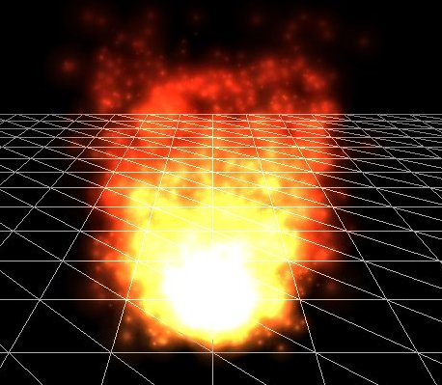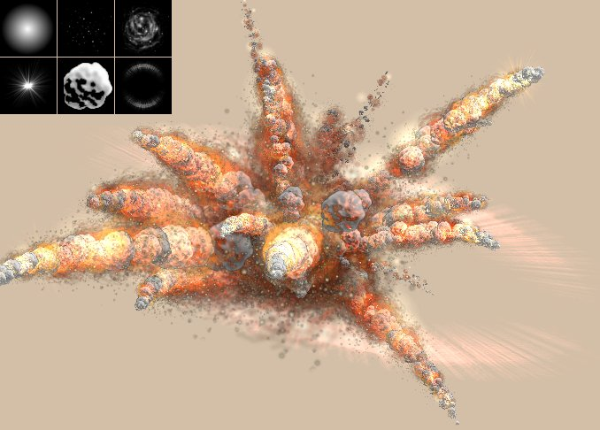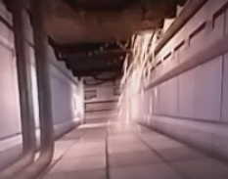

Particle Cycle

Each particle goes through the same cycle. A particle is spawned at a given location, and with a given starting velocity. Forces such as gravity, wind velocity, air resistance and buoyancy can be applied to the particle each frame to alter its velocity. The current velocity is also applied to the current position each frame to generate a new position.

A particle will likely reach some physical threshold (each hitting the ground) or fade or shrink with time. At the end of the cycle the particle is made inactive.

Particle Management

Due to the quantity and simplicity of particles we want to handle them in a different way to the way we might work with a level environment in a game engine.

Bad ideas:

- Creating a new mesh for every particle.
- Swapping textures on the graphics card too often.
- Calling new and delete for every particle we spawn and make inactive, as these memory management functions are relatively.

To avoid these we want to create a single mesh for each particle type and only update the minimum data which changes from frame to frame.

Double Linked Lists
To help achieve this we’ll use a pair of double linked lists. C++ has templates for these storage types in std::list

A double linked list has advantages and disadvantages when compared to an array. With an array it’s impossible to insert a new element between two existing elements without some work to move the existing items in memory. It’s also not obvious where an array ends unless we’re keeping track of it.

In a double linked list each node has the following properties:
- The data we want to store
- A pointer to the previous member
- A pointer to the next member

This makes it easier to insert a node just by changing adjacent nodes’ pointers, but it means we cannot quickly jump to the nth node using [n], the CPU must cycle through the pointers.

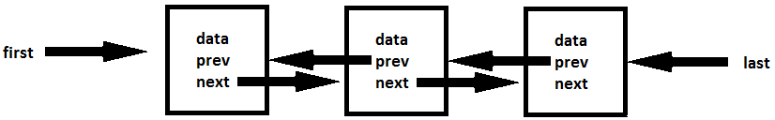

A std::list tracks the first, last and size of the list for us.

Active and Free Lists

In order to avoid creating particle data in memory every time we want a new particle, we will create the maximum number of particles we’ll ever want to render in a free list. When we want to use a particle, we’ll transfer the first free node to the end (“last”) of the active list, and set its parameters.

Over time, the particles will move through their animation until they reach a state where they should be made inactive. To find these particles, we can iterate from the first item through the list, removing particles until we find the first that should still remain active, and then we stop. The particles are kept in order of age.

We call this system a queue; we “push” an item to one end of the queue and “pop” items from the other end.

When we remove an item we add it back onto the free queue. This way we can avoid calling new and delete on particles at run time.

Some particle systems can be switched on and off, either by a player or by some timed event in the game. Using these lists supports this. When a particle generator gets switched off, we can continue to process and remove particles from the active list over time. We don’t need to destroy all currently animating particles when the generator is disabled.

Exercise 01 – Single Particle

To begin with we’ll make a single particle, rendered from a new class which will become our particle generator.

- Base a new class on your Model class by making a copy of the Model.h, cpp and hlsl. Call this ParticleGenerator.

- Make sure you add #pragma once to the top of the header file. This command stops errors occurring when header files become included in a cpp file multiple times, and in a large practical project you’ll probably want it at the top of almost every header file.

- Add a struct to the top of your header file to hold the unique data for individual particles.
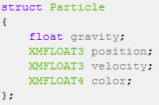

- You can remove all references to the ObjFileModel code from your generator class, instead we’ll use a hard coded array representing a single quad, with six vertices for two triangles. This is much like the way we created the cube.
int ParticleFactory::CreateParticle()
{
HRESULT hr = S_OK;
XMFLOAT3 vertices[6] =//verts for the quad NOTE: could be changed to make different shapes??
{
XMFLOAT3(-1.0f,-1.0f,0.0f),
XMFLOAT3(1.0f,1.0f,0.0f),
XMFLOAT3(-1.0f,1.0f,0.0f),
XMFLOAT3(-1.0f,-1.0f,0.0f),
XMFLOAT3(1.0f,-1.0f,0.0f),
XMFLOAT3(1.0f,1.0f,0.0f),
};
D3D11_RASTERIZER_DESC rasterizer_desc;
ZeroMemory(&rasterizer_desc, sizeof(rasterizer_desc));
rasterizer_desc.FillMode = D3D11_FILL_SOLID;
rasterizer_desc.CullMode = D3D11_CULL_NONE;//sets no culling
hr = m_pD3DDevice->CreateRasterizerState(&rasterizer_desc, &m_pRasterSolid);
rasterizer_desc.CullMode = D3D11_CULL_BACK;//sets backface culling
hr = m_pD3DDevice->CreateRasterizerState(&rasterizer_desc, &m_pRasterParticle);
//create the vert buffer
D3D11_BUFFER_DESC bufferDesc;
ZeroMemory(&bufferDesc, sizeof(bufferDesc));
bufferDesc.Usage = D3D11_USAGE_DYNAMIC;//both cpu and gpu
bufferDesc.ByteWidth = sizeof(XMFLOAT3) * 6/*VERTCOUNT*/;
bufferDesc.BindFlags = D3D11_BIND_VERTEX_BUFFER;
bufferDesc.CPUAccessFlags = D3D11_CPU_ACCESS_WRITE;//edit on the cpu

hr = m_pD3DDevice->CreateBuffer(&bufferDesc, NULL, &m_pVertexBuffer);

if (FAILED(hr)) return 0;

//copy verts to buffer
D3D11_MAPPED_SUBRESOURCE ms;

//mapping = locking the buffer which allows writing
m_pImmediateContext->Map(m_pVertexBuffer, NULL, D3D11_MAP_WRITE_DISCARD, NULL, &ms);
memcpy(ms.pData, vertices, sizeof(vertices));//copy data
//unlock the buffer
m_pImmediateContext->Unmap(m_pVertexBuffer, NULL);

/*CalcModelCentrePoint();
CalcBoundingSphereRadius();*/
CompileShaders();

return 0;
}

Notice that the array here is of XMFLOAT3s, not a custom vertex structure. We will not be passing colour, texcoords or normals as part of our vertex data for this geometry, so an XMFLOAT3 represents our vertex structure.

- Update your D3D11_INPUT_ELEMENT_DESC to just be a 3 part vector. Your constant buffer for the new shader will store a worldViewProjectionMatrix first, and a color second.
WHY: with particles we often want to update the colour over time. Therefore it’s more appropriate to consider it a value which we can vary each time the shader is used, like the position, than a fixed property of the geometry.

- We’re going to make a function called DrawOne in the class to handle drawing a single particle. To start with our Draw function will just call this with a test particle, to make sure we can see it.

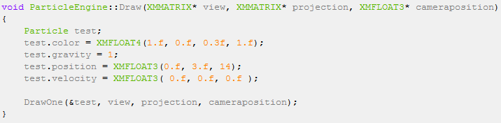

- Now to create DrawOne, which will use the parameters and stride below:

- Create a world matrix that scales to 0.3f, rotates by pi radians in the Y axis, and then translates to
one->position.
- Copy one->color into your constant buffer and update the shader with the worldViewProjectionMatrix and color. Then set the shader active and Draw your vertex buffer in DrawOne.

- Now to the particle_shader.hlsl

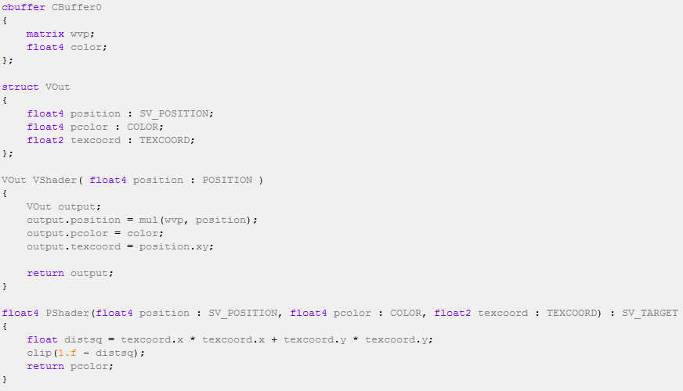

Here we are using the vertex position for a 2D texture coordinate, similar to the way we used it as a 3D texture coordinate in our cubemap in the previous tutorial.

Texture coordinates do not have to be used to sample a texture. In the pixel shader we are using Pythagoras on these values to calculate the distance from the center of the quad. If this falls outside of a circle of radius one, we clip the pixel – i.e. cancel the rendering. If the pixel is clipped we do not draw a colour to the screen, or a depth to the depth buffer. This way we can easily render a perfect circle without using a texture file.

- Run the program, and you should see a single particle hanging in space.

Exercise 02 – The Particle Generator

Now we will create a generator in Draw which creates new particles at a given rate, updates existing particles positions, draws them, and destroys any which fall below a certain height. The particles will form a fountain.

- In your header file add:
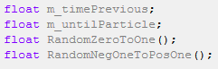
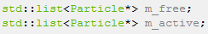

- m_free will need to be initialised with inactive particles. You can create a for loop which adds 100 new particles to the list on start up. On deconstructing you should call delete on every particle in m_free and m_active. Check your code with a breakpoint code to make sure that every particle is accounted for on exit.

- We’ll use float(timeGetTime()) to get a time stamp in milliseconds. You’ll need to add the library Winmm.lib for this. Initialise m_timePrevious with a timestamp and set m_untilParticle to a few seconds.

- Create the two functions to generate your random numbers. rand() will give you a value between 0 and 32767. Write functions to modify this to a float in the range 0 to +1 and -1 to +1.

- At the start of Draw, create a timeNow variable, and a deltaTime variable – the difference between this frame and the previous, all in seconds. Update m_untilParticle as a timer counting down to zero.
//local vars
XMMATRIX world;
UINT stride = sizeof(XMFLOAT3);
UINT offset = 0;
float timeNow = float(timeGetTime())/1000.0f;
float deltaTime = timeNow - m_timePrevious;
m_timePrevious = timeNow;
m_untilParticle -= deltaTime;

- You can get access the pointer in an iterator using (*it). Declare it as follows in your header file:
std::list<Particle*>::iterator it;//iteration list for pointing to the correct particle in the list
- When it’s time to create another particle, and if we have some in our free list, take the particle pointer from the beginning, pop it from the free list and push it to the back of the active list. Initialise all the values in the particle at this time. Try to think of some sensible values, and use the random functions to vary any of the properties. (Note that I have used a switch statement here. This is so that I can have different particle effects. Use an enum to make a list of particle effect types. This should be created within the header file)
if(m_untilParticle <= 0.0f )
{
if (m_isActive)//a bool to check if the particle engine is on or off. Make a getter/setter and use it in main
{
it = m_free.begin();//point to the beggining of the free list
//add a new particle to the back of m_active from the front of m_free
if (m_free.size() != NULL)//safety check
{
switch (type)//the name of my enum
{
case RAINBOW_FOUNTAIN:
{
m_age = 2.0f;
m_untilParticle = 0.008f;
////////////////////////initialise the particle NOTE: all of this is adjustable for different effects////////////////////////
(*it)->color = XMFLOAT4(RandomZeroToOne(), RandomZeroToOne(), RandomZeroToOne(), 1.0f);
(*it)->gravity = 4.5f;
(*it)->position = XMFLOAT3(0.0f, 1.0f, 3.0f);
(*it)->velocity = XMFLOAT3(RandomNegOneToPosOne(), 2.50f, RandomNegOneToPosOne())
////////////////////////////////////////////////////////////////////////////////////////////////
break;
}
default:
{
break;
}
}
(*it)->age = 0.0f;//set age to 0. this is used for knowing when to delete the particle

//////add the particle from the front of the available list to the back of the active list and remove it
m_active.push_back(*it);
m_free.pop_front();
}
}
else m_untilParticle = 0.001f;
}

- After creating that particle set your timer to a time until the next particle. Now we have some code to spawn particles at this given rate.

- Next in Draw, and if there are any particles in the active list, we’ll loop through them and process them. To loop through the list we use an iterator.
if (m_active.size() != NULL)//safety check
{
it = m_active.begin();//point the iterator to the front of the active list ready for processing
while (it != m_active.end())//move all of the particles
{

switch (type)
{
case RAINBOW_FOUNTAIN:
{

Change the velocity’s y by gravity, and update the position using the velocity.
/////////////////////////ALL of this is adjustable for different effects///////////////////////////////////////////////////////////
(*it)->age += deltaTime;
(*it)->velocity.y -= (*it)->gravity*(deltaTime);
(*it)->position.x += (*it)->velocity.x*(deltaTime);
(*it)->position.y += (*it)->velocity.y*(deltaTime);
(*it)->position.z += (*it)->velocity.z*(deltaTime);
///////////////////////////////////////////////////////////////////////////////////////////////////////////////////////////////////
break;
}
default:
{
break;
}
}
world = XMMatrixIdentity();
switch (type)
{
case RAINBOW_FOUNTAIN:
{
/*set scale and world transforms here*/
break;
}
default:
{
break;
}
world *= XMMatrixTranslation((*it)->position.x, (*it)->position.y, (*it)->position.z);

//constant buffer stuff for shader
pcb.wvp = (world) * (*view)*(*projection);
pcb.color = (*it)->color;

m_pImmediateContext->VSSetConstantBuffers(0, 1, &m_pConstantBuffer);
m_pImmediateContext->UpdateSubresource(m_pConstantBuffer, 0, 0, &pcb, 0, 0);

//set the shader objects as active
m_pImmediateContext->VSSetShader(m_pVShader, 0, 0);
m_pImmediateContext->PSSetShader(m_pPShader, 0, 0);
m_pImmediateContext->IASetInputLayout(m_pInputLayout);

m_pImmediateContext->IASetVertexBuffers(0, 1, &m_pVertexBuffer, &stride, &offset);

m_pImmediateContext->IASetPrimitiveTopology(D3D11_PRIMITIVE_TOPOLOGY_TRIANGLELIST);

m_pImmediateContext->RSSetState(m_pRasterParticle);//set backface culling to on
m_pImmediateContext->Draw(6, 0);//draw the particle
m_pImmediateContext->RSSetState(m_pRasterSolid);//set backface culling to off

- Use a threshold to decide when to remove a particle. Maybe use a y value below the starting position, or add an age member to the Particle struct. At the end of the iterator loop you can call it++; to move the iterator to the next item in the list. But be careful – if you remove the item that iterator is currently on, what happens? You could also consider remove_if() for this job, or pop_front() if you know the oldest particles are at the front of the list.

if ((*it)->age >= m_age)//check the age of the current particle
{
it++;
m_active.front()->age = m_age;
m_active.front()->position = { (RandomNegOneToPosOne() + position.x * 10)*(RandomZeroToOne() * 10),position.y + 5.0f, /*position.z*/ camera_pos->z + 7.0f };
m_active.front()->velocity = { /*RandomNegOneToPosOne()*/0.0f, 4.50f, RandomNegOneToPosOne() };
m_free.push_back(m_active.front());//move the (now previously) current active particle to the back of the pool
m_active.pop_front();//remove the particle
}
else it++;
}//end of while
}//end of if(m_active.size()!=NULL)

You should now have a fountain of particles in your scene. If you find the particles are disappearing too quickly or you can’t find them, try these values to initialise them:

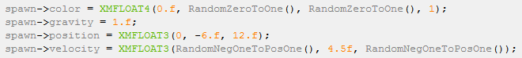

Additional Exercise 01 – Camera Facing Particles

So far you’ve just rotated the particles by pi radians so that you can see the front face when the camera is at (0,0,0). If you move the camera around, you might notice the particles appear flat. Facing the particles towards the camera will hide the fact the particles are quads, and give the impression that they are all spherical. The particles can then be viewed from any angle. You can also turn on backface culling (see above code). Review your past code using XMMatrixLookAtLH() code and use this function to create a matrix which faces the particles to the camera. You would then call this function when you multiply your world transforms, as follows:
world *= XMMatrixRotationY(XMConvertToRadians(LookAt_XZ(camera_pos->x, camera_pos->z)));//this makes the quad face the correct way (always facing the camera)

Additional Exercise 02 – Keyboard Controlled Fire

Create a particle system where particles start off yellow, turn red and later turn black. Have the particles start with an initially small velocity, and use a negative gravity value so they float upwards rather than falling downwards. Have a keyboard key assigned to switch the fire on and off. Make sure existing particles continued to be updated, rendered and deactivated even when new particles are not being created.

